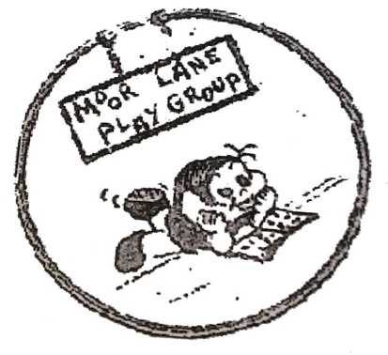

Moor Lane Preschool

Moor Lane

**Preschool Playgroup**

**Information for parents**

**FOR enquiries please contact us on 07767361909**

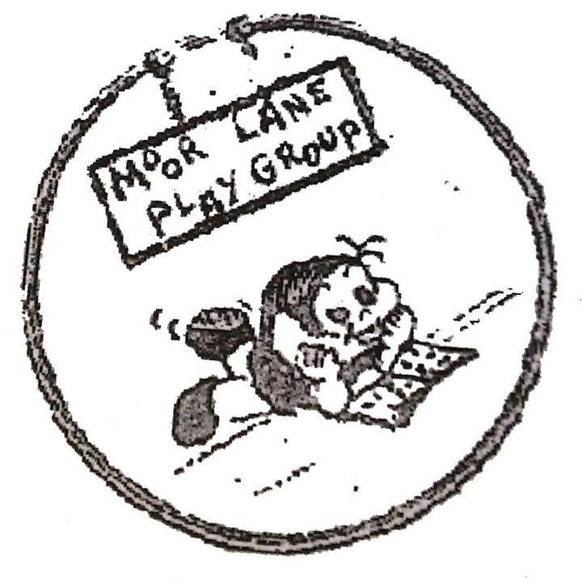

**All About Us**

**Information for Parents**

Sunny Bank Church, Moor Lane, Downley, HP13 5YP

**Telephone – 01494 443808**

**07767361909**

**Email:moorlanepreschool@btconnect.com**

**FEES –** Fees are payable for two year olds that are not eligible for two year old funding (if you are unsure please speak to a member of staff). At present it is £12.00 per session, payable in advance, within the first two weeks of every half term

**All children at Moor Lane Preschool attend a small group activity (the group depends on their starting age)**

**SALLEY GROUP** (Structured Activities for Language and Literacy in the Early Years) - this is a programme that was developed by Speech and Language Therapists. The children take part in SALLEY the last three terms before going to school, attending two sessions per week. They take part in a wide range of activities, including learning to do “good sitting”, looking and listening, communication and memory games and learning phonics and other skills needed for reading. The groups have no more than six children and gives them a good start for when they move onto school. SALLEY is a squirrel puppet!  **SPIRALS** (Speaking, Playing, Investigating, Reading and Language Skills) This involves no more than four children and one practitioner, in a quiet area for two sessions per week where they take part in activities and games that encourage communication and pre reading skills. SPIRALS is a teddy bear that joins the group **PALS –**This is a programme that encourages the children’s social skills by using puppets in role play, to encourage friendships, sharing, taking turns and dealing with emotions

**Parents are more than welcome to view any of the above sessions, please speak to a member of staff to arrange this.**

“Providing a safe and happy atmosphere in which children can learn through play."

[](http://www.bing.com/images/search?q=clipart+hands&FORM=HDRSC2#view=detail&id=7CAFBDDFDE34C3944BDAB9CE236B3E1B95B360BA&selectedIndex=336)

Monday – Friday 9.15 – 12.15

places availalble for children from 2 – 4 years

Now takes funded two year olds

Moor Lane preschool playgroup was first opened in Autumn 1972, it is a privately run preschool owned and supervised by Cathy Piercy, assisted by 6 staff,. All the staff are DBS checked, have relevant Early Years Qualifications, have undergone safeguarding training and are first aid trained. Our ratios are 1:6 (3-4 year olds) 1:4 (2 year olds). We aim to ensure each child reaches their full potential in a friendly, safe environment.

* We pledge to enable every child at every age to access all areas of the curriculum, through play, small group sessions and 1:1 work with their key worker, enabling all the children to feel comfortable, confident, safe and secure.
* We encourage children to work as part of a group and individually, taking turns and sharing by understanding acceptable codes of behaviour
* We teach children to understand good practice with regards to exercise, eating and personal hygiene and other self-help skills (i.e. fastenings, dressing, putting on shoes)
* We endeavor to encourage children to be cheerful and friendly, to use common sense, to be patient, honest, polite and enthusiastic. We encourage them to have a go without fear of failure
* We expect them to be polite and to listen to each other, us and their carers. We expect them to treat everyone with equal respect, to include everyone, to learn from their mistakes and to ask for help if needed.

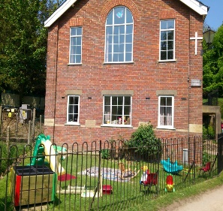

**Here at Moor Lane Pre-school our dedicated team are committed to partnering with parents to enable children to develop, learn and grow in a caring nurturing environment.**

Parents or carers are invited to view the preschool to ensure we can meet the needs of their children

* A copy of the preschool prospectus and the policies are available on the parents table containing information on policies and practices.
* During the half term before your child starts with us, we encourage you to visit with them, to attend a session to meet the staff,

during which:

* The children are able to explore the environment and resources.
* You can meet your child’s keyworker and fill out any relevant forms, discuss routines and have the opportunity to ask any questions

**On the first day**

* Allow plenty of time, your child won't be prepared for you to just drop him/her off and leave on the first day, so be prepared to stay around until he/she settles
* When you've said your goodbyes, try not to worry. If there is a problem, we will call you, but in most cases your child will be enjoying their exciting new experience at our preschool

**What to bring on their first day –** Children can get messy, very messy, so it's best not to dress them in their favourite clothes. Aprons are provided but accidents can and do happen! Also some children do not like to wear the aprons. Please ensure your child has a coat with them and wears sensible footwear. If your child has wellies, please bring them in for your child to wear. In warmer weather please ensure your child has sun cream on and a hat

**Please label all items with your child’s name**

[](http://www.bing.com/images/search?q=children+in+the+rain+clipart&qs=n&form=QBIR&pq=children+in+the+rain+clipart&sc=0-20&sp=-1&sk=#view=detail&id=3C5CDBB49A952EA86EDA37F6A6E787DA118E48B6&selectedIndex=29)

**Problems settling in**? Some children find the experience of starting preschool stressful and still won't settle after a few weeks. Don't worry and don't blame yourself - just accept that children are all individuals and your child will get there in the end. Here are some helpful tips:-

* Find out from your child's key worker what happens once you've left.
* Try building up sessions gradually.
* Try staying with your child for extra sessions, moving away once he/she becomes engaged with an activity but not leaving the room.
* Some children will settle better if you keep your goodbyes brief - lingering may only make the whole process more painful for you and them

**Snack Time -**During the sessions, snack is offered, the children are able to sit, help prepare snack and pour their own drinks. Snack includes a rice cake/cracker/bread stick/ pitta and a piece of veg / fruit. We offer milk or water to drink, water is available at all times

**Key Person -**We operate a 'Key Person System' which means that each member of staff has a group of children for whom they have specific responsibilities. When a child joins our setting they then have a special adult who helps them to settle in and who they can relate to. The Key Person also makes regular observations of the child which assists in ensuring that the Pre-school curriculum is planned to include activities at their level, thus helping the child to achieve their full potential during their time with us.This system also helps to establish good links between the home environment and learning opportunities, as well as those within the group. We encourage parents to liaise with their child's key person to discuss progress made and any other issues which may arise. Your child’s key person will also send home a diary each week to inform you of activities your child has taken part in during that week.